The detailed session schedule of Mineral Engineering and Physicochemical Problems of Minerallurgy sessions for 16, 17 and 18 of September will be given to the participants with the conference materials.

Section
Minerals Engineering

Cierpisz S., Kowol D.: Impact of disturbances of process of coal washing in a jig on changes of separation density – laboratory tests
Fečko P., Tora B.: Biodegradation of soil from Leoš Janáček airport in Mošnov
Foszcz D., Niedoba T., Tumidajski T.: Chosen problems of balancing of copper ores beneficiation products
Galos K.: New mineral policy of the european union
Gawenda T., Niedoba T., Przybycień K., Tumidajski T.: Application of genetic algorithms to modeling of mineral processing operations
Gawenda T.: Main aspects of hard mineral raw materials comminution in high pressure grinding rolls
Hala H. Abd El-Gawad, El-Hussiny N.A., Wassf M.A., Kalifa M.G., Iskander B.A., Shalabi M.E.H.: Briquetting of Rosetta ilmenite ore with different organic binder and its reduction in hydrogen in the temperature range of 800 – 1200 ⁰C
Iskander B., Kamel N.A.: Mechanical properties of biodegradable bone cement composites
Hołda A., Kisielowska E., Niedoba T.: Chemical and biological analysis of chromium waste
Kamiński S., Kamińska D.: Measurement of materials granulation in minerallurgy by application of modern electronic measuring devices
Krawczykowska A., Trybalski K., Krawczykowski D.: Application of neural networks models to lithological composition determination of copper ore
Krawczykowski D., Trybalski K.: Usefulness of the particle size distribution laser analyzes on balancing of hydrocyclone classification products
Lenartowicz M., Kowol D., Łagódka M., Matusiak P.: Laboratory tests on the impact of screen parameters on the characteristics of pulsatory movement of water in a pulsatory jig
Lewkiewicz-Małysa A., Konopka E.: Protection of natural rock mass properties as a storage yard of the deposit waste-water
Małysa E., Iwańska A.: Influence of different flotation reagents on rising velocity of air bubbles
Marciniak-Kowalska J., Wójcik-Osip E.: The study of the process of lamella coal flotation
Marwa A. G. E., Mohamed F.M., El-Bohy S.A.H., Caramen M.S., Shalabi M.E.H.: Factors affected the performance of fire clay refractory bricks
Modrzewski R., Wodziński P.: Oscillating motion of a double-frequency screen
Naziemiec Z., Saramak D.: The analysis of changes in pressing force impact on material in HPGR compression zone
Niedoba T.: Multidimensional distribution functions of grained materials features by application of non-parametric approximations of marginal distribution functions
Nowak A., Surowiak A.: Evaluation of the adequacy of fine coal particles (<2 mm) separation during desulphurization process performed in spiral separators

Osoba M., Lutyński A.: Technological selection of pulse water jigs during the designing process
Özün S., Atalay Ü., Kadıoğlu Y.,K.: Investigation of upgrading of Nepheline syenite ore by a new collector
Peszko B., Niedoba T.: Influence of particle shapes on joined particle size distribution function given by Coulter Counter method
Szponder D., Trybalski K.: Determination of fly ashes properties with use of different research methods and measuring devices
Tajchman Z.: Regressive model of ultrafine particles classification process
Wasielewski R., Tora B.: Solid secondary fuels
Zawada J., Chochoł K.: Experimental research of crushing energy
Section

Physicochemical Problems of Minerallurgy
Amer A.: Hydrometallurgical processing of low grade Egyptian magnesite
Aranowski,R., Hupka J.: Rheological properties of activated sludge suspension
Brożek M., Młynarczykowska A.: Probability of detachment of particle determined by the stochastic model of flotation kinetics
Grodzka J., Pomianowski A.: The hydrogen-bond puzzle
Heim A., Obraniak A., Gluba T.: Change in the properties of beds granulated in disc granulators
Ibrahim S.S., El-Midany A.A., Boulos R.T.: Economic preferences of mechanical activation over mineral beneficiation for phosphate rock direct application
Ibrahim S.S., El-Midany A.A., Boulos T.R.: Effect of intensive mechanical stresses on phosphate chemistry as a way to increase its solubility for fertilizer application
Kołodziejczak-Rodzimska A., Krysztafkiewicz A., Jesionowski T.: Zinc oxide obtaining from aqueous solutions of KOH and Zn(CH₃COO)₂
Korkosz, A., Janczarek, M., Aranowski, R., Rzeczuła, J., Hupka, J.: Efficiency of deep bed filtration in treatment of swimming pool water
Kowalczuk P., Chmielewski T.: Changes of electrode potential in non-oxidative leaching
Kursun I.: Flocculation behavior and adsorption –desorption mechanism of albite concentrate with polymers
Malewski W., Jesionowski T., Ciesielczyk F., Krysztafkiewicz A.: Dispersion characterization of colloidal silica at the subsequent stage of silica sol preparation
Malicka-Soczka A., Domka L., Kozak A.: Kaolin modified with a silane compound as a filler used in rubber industry
Modrzejewska-Sikorska A., Ciesielczyk F., Krysztafkiewicz A., Jesionowski T.: Synthesis and characterization of precipitated copper(II) silicates
Modrzewski R., Wodziński P.: The results of process investigations of double-frequency screen
Nowak P.: Adsorption of surface-active agents at copper sulfides
Nowik-Zając A., Kozłowski C., Walkowiak W.: Transport of perrhenate anions across plasticizer membranes with basic ion carriers
Olejnik P.T.: Kinetics of breaking up ceramic bulk considering grinding media contact points
Pośpiech B., Walkowiak W.: Studies on iron(II) removal from chloride aqueous solutions by solvent extraction and transport through polymer inclusion membranes with D2EHPA
Raslan M. F.: Mineralogical and physical separation of samarskite-y from stream sediment of Ras Baround Area, Central Easter Desert, Egypt
Sadowski Z., Polowczyk I., Frąckowaiak A., Chibowski S.: Bioinspired synthesis of calcium carbonate colloid particles
Saleh A.M.: A study of the performance of second order models in two phase models in iron ore flotation
Siwińska-Stefańska K., Krysztafkiewicz A., Ciesielczyk F. Paukszta D., Sójka-Ledakowicz J., Jesionowski T.: Physicochemical and structural properties of TiO₂ precipitated in an emulsion system
Ulewicz M., Lesińska U., Bocheńska M.: Transport of lead across polymer inclusion membrane with p-tert-butylcalix[4]arene derivative
Yildirim M., Akarsu H.: Preparation of magnesium oxide (MgO) from dolomite by the leach-precipitation-pyrohydrolysis process
Jerzy Gęga, Władysław Walkowiak., Leaching of zinc and manganese from spent zinc-carbon batteries using sulfuric acid solutions
The united Organizing Committee warmly invite you to participate in joined conferences: XIV International Conference of Mineral Processing and XLVI Symposium on Physicochemical Problems of Mineral Processing, which will be held between 16-18 of September, 2009 in Krakow-Niepołomice.

Second circular
XIV INTERNATIONAL CONFERENCE OF MINERAL PROCESSING 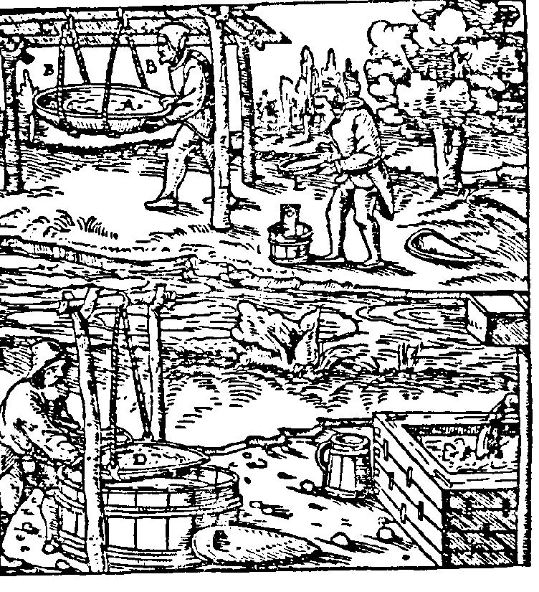

XLVI SYMPOSIUM
PHYSICOCHEMICAL PROBLEMS OF MINERAL PROCESSING

Under patronage of JM Rector AGH
Prof. Antoni Tajduś

Kraków-Niepołomice
September 16-18, 2009

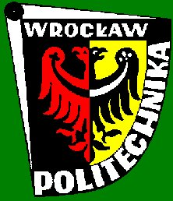

Organizers
AGH University of Science and Technology
Department of Mineral Processing and
Environmental Protection

Wroclaw University of Technology
Department of Mining Engineering

Silesian University of Technology
Department of Mineral Processing and Waste
Utilization
Polish Academy of Science
Committee of Mining, Section of Mineral Raw
Materials Utilization

The joined conferences provide a great opportutnity to meet representatives of science and industry working with mineral processing, raw materials utilization and ecology.
The papers of the conference will be published in the volume 4/2009 of the Górnictwo i Geoinżynieria quarterly and volume 44 of the Physicochemical Problems of Mineral Processing annual before the conference.
The registration fee is 300 EURO per person. The fee covers room, board and conference proceedings. The cost for accompanying person is 250 EURO.
All fees should be transferred to the following bank account number:

Fundacja “Nauka i Tradycje Górnicze”
Bank PeKaO S.A. I O/Kraków
nr 06 1240 1431 1111 0000 1045 2923

with foot-note

“Konferencja przeróbki 2009” + name of participant

The conference will be held in hotel „Novum” in Niepołomice, address: Hotel Novum, ul.Grunwaldzka 15H, 32-005 Niepołomice, tel./fax (012) 279 89 00. The access map is given on the hotel’s web-site.
(http://www.hotelnovum.pl).

IMPORTANT DATES
September, 1, 2009
Registration fee deadline

September, 16, 2009
Beginning of the conference
Conference schedule

WEDNESDAY, 16.09.2009

12⁰⁰-15⁰⁰ Reception
13⁰⁰-15⁰⁰ Lunch
15⁰⁰ Official opening of the conference
15⁰⁰-18⁰⁰ Plenary session
coffee break during plenary session

19⁰⁰ Traditional regional diner
THURSDAY, 17.09.2009
8⁰⁰ – 9⁰⁰ Breakfast
9⁰⁰ –12⁰⁰ Parallel sessions of MI and PPM
12⁰⁰-13⁰⁰ Lunch
15⁰⁰-17⁰⁰ Parallel sessions of MI and PPM
17¹⁵ Organizers meeting
19⁰⁰ Gala diner

FRIDAY, 18.09.2009

9⁰⁰ - 10⁰⁰ Breakfast
10⁰⁰-12⁰⁰ Parallel sessions of MI and PPM
12⁰⁰–12¹⁵ Summary and conference closing
12⁰⁰–13⁰⁰ Lunch

Conference sponsors:

Urząd Miasta i Gminy
Niepołomice
Media patron:
